Paper Title

Author 1 Name¹, Author 2 Name², … and Author N Name^{N}

¹ Department,Name of the Organization, City, Country: Email
²Department,Name of the Organization, City, Country: Email
…
^{N}Department,Name of the Organization, City, Country

Received ## Mon. 20##, Revised ## Mon. 20##, Accepted ## Mon. 20##, Published ## Mon. 20##

Abstract: The abstract should be no more than 150 words, in the first page with title, authors' name and keywords. Normal text is Times New Roman Font size 9 with single line space.
Keywords: Keyword1, Keyword2, … , KeywordN

List 4 To 8 Words Which Related To The Paper, Times New Roman Font Size 10

Introduction (Heading 1)
The introduction text and the normal text is times new roman font size 10.
The total pages of the whole paper must be not more than 10 pages.
Consider the following structure for the experimental paper:
- Introduction/aim/background
- Methodology
- Results and discussion
- Conclusion
- Acknowledgements
- References
Next Main Heading

sub-Heading A
First, confirm that you have the correct template for your paper size. This template has been tailored for output on the 21cm X 28cm Paper Size.

sub-Heading B

Theory

Equations
The equations are an exception to the prescribed specifications of this template.
       

Some Common Mistakes

Results and Discussion
After the text edit has been completed, the paper is ready for the template. Duplicate the template file by using the

- Table Type Styles
Table Head | Table Column Head
Table Head | Table column subhead | Subhead | Subhead
copy | More table copyª

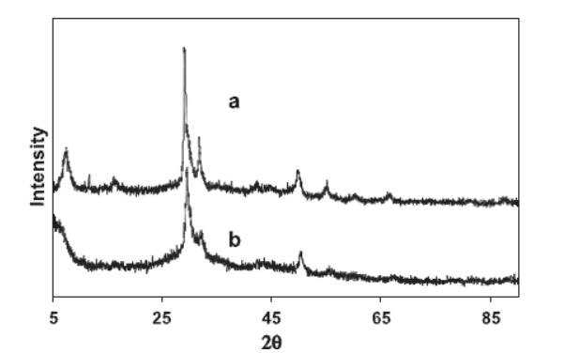

- Example of a figure caption. (figure caption)

Data availability statement
The data used are included in the manuscript
Conflict of interest
The authors declare no conflict of interest to influence the work in this paper

Acknowledgment

conclusions
Normal text is Times New Roman Font

references
The style of the references must be according to IEEE style.
Journal article [Ref number] Author’s initials. Author’s Surname, “Title of article,” Title of journal abbreviated in Italics, vol. number, issue number, page numbers, Abbreviated Month Year.
[1] F. Yan, Y. Gu, Y. Wang, C. M. Wang, X. Y. Hu, H. X. Peng, et al., "Study on the interaction mechanism between laser and rock during perforation," Optics and Laser Technology, vol. 54, pp. 303-308, Dec 2013.

