Review Article

Selenium nanoparticles: A review of their plant-mediated synthesized and evaluation their biomedical applications

Zainab A. Sattar ¹, Ahmed Mishaal Mohammed ^{2,*} , Yousif H. Khalaf ³
^{1,2}* Department of Chemistry, College of Science, University Of Anbar, Ramadi, Iraq
³ Department of Clinical Lab. Sciences, College of Pharmacy, University Of Anbar, Ramadi, Iraq
* Email: zai22s3006@uoanbar.edu.iq, Tel: 07822020125
Abstract
Nanotechnology holds great potential for a variety of biological applications. The chemical methods often require harsh conditions, expensive equipment, and produce toxic byproducts. Green synthesis using plant extracts provides a more eco-friendly, low-cost, and sustainable alternative that can achieve high yields. Various plant materials, including leaves, roots, tubers, fruits, peels, seeds, and herbs, have been successfully used for the green synthesis of Selenium nanoparticles (Se-NPs). The phytochemicals present in these extracts, such as flavonoids, alkaloids, and polyphenols, facilitate the reduction of selenium ions and stabilize the nanoparticles. The characteristics of the Se-NPs, such as size, shape, and stability, can be tuned by controlling the synthesis parameters and the choice of plant extract. The biogenic Se-NPs exhibit a range of beneficial properties that make them attractive for diverse biomedical applications. These include antioxidant, antimicrobial, anti-inflammatory, and anticancer activities. The Se-NPs can also be used as drug carriers and for wound healing. Compared to chemically synthesized Se-NPs, the green-synthesized counterparts are more biocompatible and less toxic, making them safer for biomedical use. Overall, the green synthesis of Se-NPs using plant extracts combines the unique properties of selenium with the advantages of natural phytochemicals, offering a promising approach for developing safe and effective biomedical applications.
Keywords: Green synthesis; Selenium nanoparticles; Plant extracts; Bio-medical applications
Introduction
Nanotechnology is the capacity to observed, measure, control, assemble, and manufacture materials at the nanoscale to translate the nanoscience theory into practical applications [1]. Nanotechnology was defined as "a science, engineering, and technology conducted at the nanoscale. An important trace element, selenium has a number of biological properties, such as anti-inflammatory, chemo preventive, and antioxidant properties [2]. Selenium is found in nature in two forms: organic (seleno methionine and seleno cysteine) and inorganic (selenite and selenate). The elemental (Se⁰) is naturally insoluble and can form selenium nanoparticles (Se-NPs). Due to their increased bioavailability, reduced toxicity, and enhanced biocompatibility over inorganic selenium compounds. Nanotechnology has enabled the development of selenium nanoparticles (Se-NPs) with unique properties and applications in biomedical sciences [3]. Green synthesis methods using bacteria, fungi, algae and plants produce Se-NPs in an eco-friendly manner. The capping agents from these biosources can enhance the biocompatibility and biological effects of Se-NPs [4,5]. Se-NPs synthesized through these methods show promise in various fields, particularly in biomedicine, due to their antioxidant, antimicrobial, and anticancer properties. The choice of synthesis method significantly influences the properties and applications of Se-NPs, with green synthesis gaining popularity for its environmental benefits and lower toxicity [6,7].
- Synthesis of Selenium nanoparticles
Selenium nanoparticles (Se-NPs) can be synthesized using various chemical methods such as, Sol-Gel Process, Reduction of Selenium Salts, Microwave and Sonochemical Synthesis. In addition to physical methods such as, Pulsed Laser Ablation, and Vapor Phase Deposition, which vary in complexity, cost, and environmental impact, because they often require harsh conditions, expensive equipment, and produce toxic by-products [8]. As shown in Figure.1.
Compared to physical and chemical synthesis approaches, the green synthesis of Se-NPs utilizing plant extracts is a safer and more environmentally friendly process [9]. Plant extracts have the ability to function as stabilizing and reducing agents, which makes it easier to synthesize stable Se-NPs in a single step [10]. The phytochemicals included in plant extracts, including polyphenols, alkaloids, and flavonoids, are essential for stabilizing the resultant Se-NPs and reducing selenium precursors [11].
Based on the search results, the study that presented by, Jay,V., et.al [12] to synthesis, characterization and antioxidant potential of selenium nanoparticles which was synthesized by Allium sativum and Aloe vera extracts, which observed as hollow and spherical particles in size ranging from 7-48nm and 9-58nm respectively. Several plant extracts was used in the study by Cittrarasu, V., et.al. That have been effectively used for the green synthesis of selenium nanoparticles (Se-NPs) such as, Extract of Ceropegia bulbosa tubers that showed Se-NPs that were quickly produced using C. bulbosa tuber extract had strong antibacterial activity, considerable cytotoxicity against breast cancer cells, and larvicidal activities against dengue vectors [13].
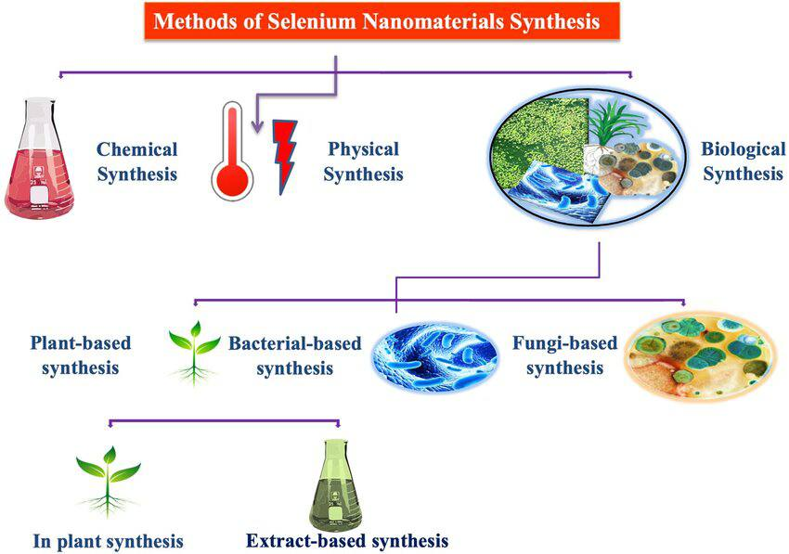
Figure.1: Different routes for the synthesis of Se-NPs
Se-NPs synthesized using Murraya koenigii (curry leaf) berry extract, Yazhiniprabla, M., and Vaseeharan, B. [14], showed effective antioxidant capacity and antibacterial activity against S. mutans, E. faecalis, S. sonnei, and, P. aeruginosa. Depending on study by Vennila, K., et.al. [15], selenium nanoparticles and other (NPs) were synthesized using Spermacoce hispida aqueous leaf extract (Sh-ALE), demonstrated strong antibacterial, anti-inflammatory, and anticancer effects against human cervical cancer cells.
The green of Se-NPs by simple mixing of Withania somnifera (W. somnifera) leaves extract and selenious acid (H₂SeO₃) solution, were found to possess significant antioxidant activity (IC50 – 14.81 μg/mg) and considerable antibacterial activity on B. subtilis, K. pneumonia, and S. aureus, antiproliferative, effects of Se-NPs possess great growth control against A549 cells (IC50 at 25 μg/ml) by Sivaraj, R., et.al, [16]. Othman, M. S., et. al, [17]. Studied the effects of Se-NPs on MCF-7 cells that inhibit proliferation using Carvacrol on human breast cancer MCF-7cells demonstrated the potential of Se NPs-CV therapy to efficiently and viability in a dose-dependent manner. The potential anti-inflammatory and anticancer properties of Se-NPs, which are synthesized using clove extract (Syzygium aromaticum) indicated potential anti-ageogenic effects, antioxidant activity (IC50 value: 0.437 µg/mL), and antibacterial effectiveness against the bacterial pathogen S. species. Biocompatibility was also confirmed in toxicity tests conducted on Artemia nauplii, by Nagarajan, K., et.al, [18]. The presented study by Ferdsadegh, B., et.al [19], focuses on the biogenic synthesis of selenium nanoparticles (Se-NPs) using Pelargonium zonale leaf extractto evaluate the antibacterial and antifungal activities of the synthesized Se-NPs against E. coli, S. aureus (G⁺) bacteria and C. coccodes and P.digitatum, which observed that the created NPs had higher inhibition rate toward the Gram-positive bacteria and pathogenic fungus. The walnut (Juglans regia L.) leaf extract has been used for the green synthesis of the Se-NPs and the obtained results indicated that spherical and monodispersed Se-NPs with a mean particle size of 150 nm were formed and gave high activity as antibacterial against E. coli and S. aureus [20]. Tarragon extract was used to perform green nano-biosynthesis of selenium nanoparticles by Yilmaz, M. T., et.al, [21]. And the Se-NPs synthesized giving rise of formation in the shape of quasi-spheres without clustering with the sizes range (20-50) nm with high thermal stability. And these (NPs) could remarkably high activity as antibacterial toward many types of pathogenic bacteria. Green synthesis of Se-NPs using various source of biomedical plants as extracts such as, Spirulina platensis, Calendula officinalis L., and Enicostema axillare, that gave high capable to producing Se-NPs with spherical morphologies and ranging size between (10-180) nm relatively. Furthermore, high activity in various biological and industrial applications [22-24].
Based on the search results in recent years, it has given promising results for the use of plant extracts as reducing and synthesizing agents of Se-NPs including, solanum nigrum fruit, Artemisia chamaemelifolia, Azadirachta indica leave, Amphipterygium glaucum leaves, Pistachio vera L (Siirt pistachio), Melia azedarach leaves, Crataegus monogyna, Tea, Herb, Moringa oleifera, Orthosiphon stamineus Leaf, Green Coffee, marine microalgae, and Nannochloropsis oceanica that yield the most stable selenium nanoparticles (Se-NPs) are those containing high levels of poly-phenolic compounds, such as flavonoids and phenolics. These compounds are effective at synthesizing Se-NPs with high stability and biological activity in medical field [25-37].
- Characterization of Se-NPs
Characterization of Se-NPs is essential to understand their properties and potential applications. Common techniques include:
- UV-Vis Spectroscopy: Used to confirm the formation of Se-NPs and assess their optical properties.
- High-Resolution Transmission Electron Microscopy (HR-TEM): Provides information on the size, shape, and morphology of Se-NPs.
- Dynamic Light Scattering (DLS): Measures the size distribution and stability of Se-NPs in colloidal solutions.
- Fourier Transform Infrared Spectroscopy (FT-IR): Analyzes the chemical bonding and functional groups present on the Se-NPs.
- Thermo-gravimetric Analysis (TGA): Evaluates the thermal stability and composition of Se-NPs.
These techniques and other techniques help in optimizing synthesis methods and enhancing the biological activity of Se-NPs for applications in medicine and nanotechnology [38-42].
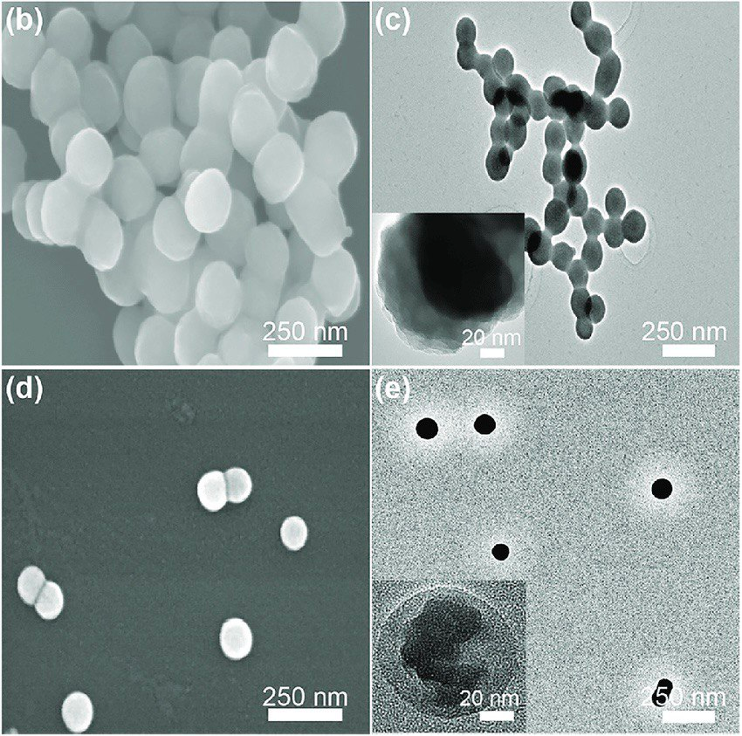
b) SEM and (c) TEM images of Se-NPs. (d) SEM and (e) TEM images of Se-NPs The insets in (c) and (e) are HR-TEM image of Se-NPs

4. Biomedical applications of Se-NPs
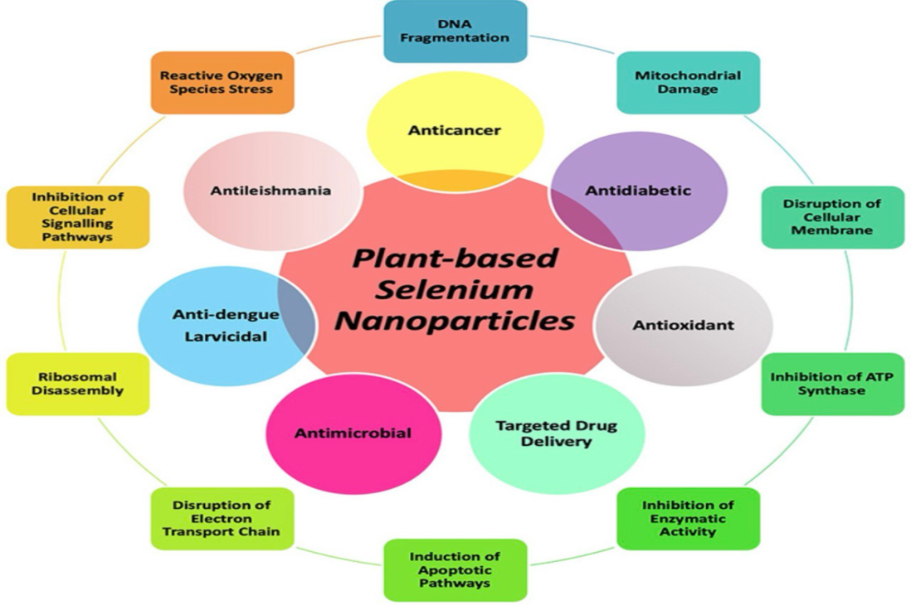
The versatile biomedical applications of selenium nanoparticles highlight their great potential to revolutionize various fields of medicine and healthcare [43]. Se NPs have been extensively studied in various medical fields due to their superior performance over elemental Se. Se-NPs have improved bioavailability while being less harmful. Nanoparticles, especially Se-NPs, have immunomodulatory, antioxidant, and anti-inflammatory properties [44]. This is shown in Figure 2. A detailed description of the biological properties of Se-NPs can be found here. We also outline recent advances in targeted strategies and new applications. [45].
Figure 2: Plant-based Se-NPs' potential for biomedicine is explained by the inner circle, while Se-NPs' mechanistic methods are explained by the outer circle [46].
  - Drug delivery applications
Se-NPs' distinct physicochemical characteristics make it possible to employ them as Nano-carriers for the precise and regulated delivery of medicinal drugs.
Se-NPs can increase a drug's bioavailability, stability, and solubility, hence boosting its therapeutic efficacy. In addition, Se-NPs can be delivered to specific tissues or cells more selectively by functionalizing them with a variety of targeting ligands [47,48].
  - Anti-cancer properties
Selenium nanoparticles (Se-NPs) have demonstrated promising anticancer effects through several mechanisms:
- Apoptosis induction: Se-NPs have the ability to cause cancer cells to undergo apoptosis, especially when doing so via the intrinsic apoptotic route. They cause the activation of caspases 3/7/9 and change the expression of proteins linked to apoptosis, such as death receptors and surviving [49].
- Proliferation inhibition: It has been demonstrated that Se-NPs, in a dose-dependent manner, inhibit the proliferation of many cancer cell lines, including those from the breast, prostate, lung, liver, and colon [50].
- Effects on antioxidants and cytoprotection: Se-NPs have the ability to scavenge reactive oxygen species and free radicals, shielding normal cells from oxidative damage while specifically causing oxidative stress in cancer cells [51].
- Effects on immunity: By stimulating the production of pro-inflammatory cytokines and natural killer cells, serine nucleic acids (Se-NPs) can boost the immune response and inhibit tumor growth in animal models [52].
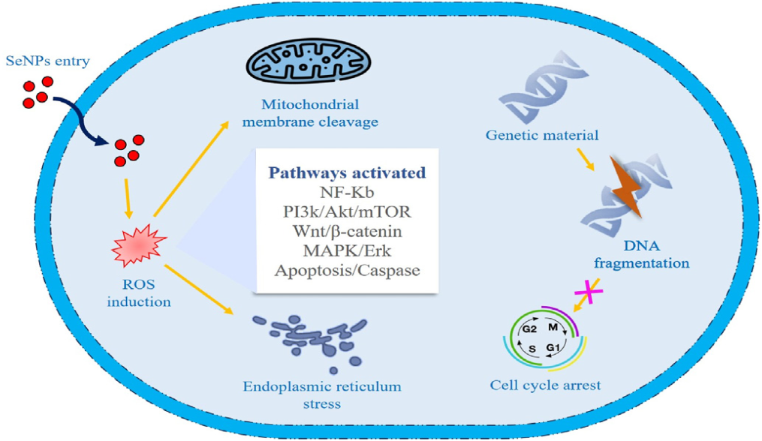
Overall, the unique properties of Se-NPs, including their low toxicity, high bioavailability, and multifaceted anticancer mechanisms, make them a promising therapeutic approach for cancer treatment. As shown in Figure 3.
Figure 3: Illustration the bio-role of selenium nanoparticles in cancer [53].
  - Anti-oxidant properties
Selenium nanoparticles (Se-NPs) have shown potent antioxidant properties, making them promising active agents. They can scavenge. Their antioxidant activity has been shown to be size-dependent, with smaller Se NPs having exhibiting greater radical-scavenging ability. In addition to that, Se-NPs can protect normal cells from oxidative stress induced by various toxicants like heavy metals, chemotherapeutics, and UV radiation. This cytoprotective effect is particularly useful in reducing side effects of cancer treatments [54,55].

  - Anti-microbial properties
The antimicrobial properties of Se-NPs make them a promising alternative for treating infections, especially in cases where antibiotic resistance is a concern and demonstrating significant activity against a variety of microorganisms. They have been explored for applications in wound management, oral health, and nosocomial infections. The biogenic Se-NPs have been found to be more effective Synthetic Se-NPs as agents against oral bacterial and fungal pathogens. The mechanism of action of Se-NPs includes DNA damage, protein degradation, and cell destruction. These nanoparticles can damage cell membranes and disrupt cellular processes, leading to bacterial death. [56,57].
  - Anti-inflammatory activity
The anti-inflammatory properties of Se-NPs, particularly when combined with plant extracts, make them a versatile platform for developing therapeutics to manage a wide range of inflammatory conditions [58]. It has been demonstrate that Se-NPs synthesized using plant extracts such as Thymus vulgaris (T. vulgaris) extract, exhibited potent anti-inflammatory properties, with a percentage of inhibition reaching 92.6% at a concentration of 50 μl, which has shown higher anti-inflammatory activity compared to standard values [59]. By targeting multiple pathways involved in chronic inflammation, Se-NPs have shown promise in managing conditions like rheumatoid arthritis, inflammatory bowel diseases, and neurodegenerative disorders. Their ability to concurrently reduce oxidative stress and modulate inflammatory signaling makes them a versatile therapeutic option for patients with chronic inflammatory diseases [60].
  - Role of Se-NPs in diabetes
Hyperglycemia is the hallmark of diabetes mellitus (DM), a widespread disease that afflicted 415 million adults between the ages of 20 and 79 in 2015. By 2040, it is predicted that this number would increase to 642 million. Notably, the prevention and treatment of diabetes and its aftereffects depend heavily on the discovery of a medication with several bioactivities, such as antioxidant, antihyperglycemic, and antihyperlipidemic properties [61,62].
Based on the search results, selenium nanoparticles (Se-NPs) have shown promising anti-diabetic properties in various animal studies which have demonstrated that Se-NPs can help regulate blood glucose levels, improve insulin sensitivity, protect pancreatic beta cells, and reduce oxidative stress in diabetes models [63,64]. The proposed mechanisms of action include Se-NPs' ability to scavenge reactive oxygen species, modulate inflammatory pathways, exhibit insulin-mimetic activity, and enhance insulin secretion [65]. In conclusion, while the animal data is encouraging, there is currently no evidence from human studies on the efficacy of Se-NPs as anti-diabetic agents [66]. Further clinical investigations are required to determine the feasibility and benefits of using Se-NPs for diabetes treatment in human patients. As shown in Figure 4.
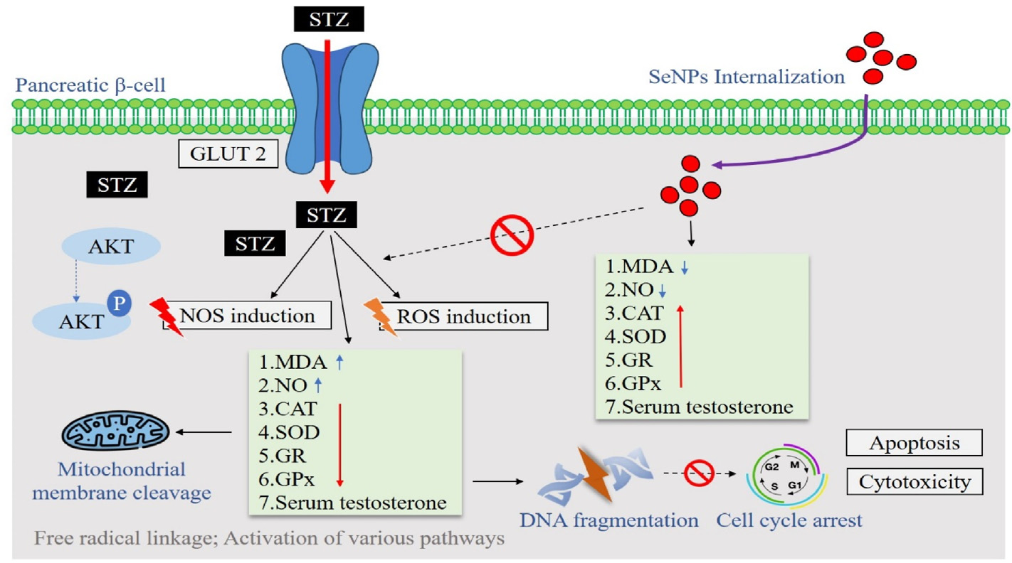
Figure 4: mechanism action of Se-NPs to improving Diabetes [65].

No | Extract  origin | Morphology and size of particles | Applications | Ref.
1 | Ceropegia bulbosa tubers | O.D = 277.5nm with spherical shape | Chemopreventive against lung  carcinoma | [67]
5 | Urtica dioica | O.D = 280 nm, nano-spheres of 40–100 nm size | Antibacterial against Gram positive and  Gram negative bacteria | [68]
6 | Murraya koenigii | Nano-spheres of 40–100 nm size | anticancer studies on human colon,  breast and hepatic cancers | [69]
7 | Withania somnifera | Spherical with a diameter of 10–  50 nm, O.D = 263 nm | Antioxidant, antimicrobial, antibacterial, antifungal | [70]
8 | Olea ferruginea | O.D = 299 - 599 nm, size = 400 nm | Anticancer (studies on mice with breast  cancer), antioxidant | [71]
9 | Terminalia arjuna | Size = 10-80 nm, O.D = 390 nm | Antioxidant | [72]
10 | Trigonella foenum-graecum L. | Nano-spheres with a 5–12 nm diameter, O.D= 355nm | Breast cancer, antimicrobial | [73]
11 | Moringa oleifera (drumstick) leaf | O.D = 270 nm  Spherical with a particles size around 400 nm | Antibacterial activity against Gram (+),Gram (-) bacteria and fungi, anticancer  activity against human breast cancer | [74]
12 | Crispum (parsley) |  | ----------------- | [75]
14 | Trigonella foenum-graecum | O.D = 200–400 nm, , 50–150 nm oval particle | Anticancer activity against human  breast cancer cells | [73]
Table 1: Summary of the reactions carried out for synthesizing Se-NPs using different plant extracts and some biomedical applications.

- Conclusion
In conclusion, Green synthesis of Se-NPs using plant extracts is a promising approach that offers several advantages. It is an eco-friendly, cost-effective, and sustainable process that leverages the reducing and stabilizing properties of natural phytochemicals present in plant materials. In addition, a variety of plant extracts have been successfully used for the green synthesis of Se-NPs, including leaves, roots, tubers, fruits, peels, seeds, and herbs. The phytochemicals in these extracts, such as flavonoids, alkaloids, polyphenols, and polysaccharides, facilitate the reduction of selenium ions and stabilize the nanoparticles. The characteristics of the Se-NPs, such as size, shape, and stability, can be tuned by controlling the synthesis parameters and the choice of plant extract and Compared to chemically and physically synthesized Se-NPs. The characterization techniques of Se-NPs such as, UV-visible, TEM, SEM, and DLS offer comprehensive insights into the physical and chemical properties of Se-NPs, essential for their application in various fields. The green-synthesized counterparts are more biocompatible and less toxic, making them attractive for various biomedical applications include, antioxidant, antimicrobial, anti-inflammatory, anticancer activities. And the Se-NPs can also be used as drug carriers and for wound healing. The resulting researches have great potential of Se-NPs for diverse biomedical applications, from treating infections to managing chronic diseases, while being environmentally friendly and sustainable.
References

[1]. Bayda, S., Adeel, M., Tuccinardi, T., and Cordani, M., “The history of nanoscience and nanotechnology: from chemical–physical applications to nanomedicine,” Molecules, 25, no 1, pp. 1–15, 2020.
[2]. Mathew, J., Joy, J., and George, S. C., “Potential applications of nanotechnology in transportation: A review,” J. King Saud Univ. - Sci., vol. 31, no. 4, pp. 586–594, 2019.
[3]. Baig, N., Falath, W., and Kammakakam, I.,“Nanomaterials: A review of synthesis methods, properties, recent progress, and challenges,” Mater. Adv., vol. 2, no. 6, pp. 1821–1871, 2021.
[4]. Kulkarni, D., Sherkar, R., Shirsathe, C., Sonwane, R., Varpe, N., Shelke, S., ... & Dyawanapelly, S. (2023). Biofabrication of nanoparticles: sources, synthesis, and biomedical applications. Frontiers in Bioengineering and Biotechnology, 11, 1159193.‏
[5]. Yousaf, B., Habib Ullah., Liu, G., Ali, M. U., Irshad, S., Abbas, Q., and Ahmed, R., “A comprehensive review on the environmental transformation of selenium: Recent advances and research perspectives ,” Environmental chemistry and Health, vol. 41, no. 2., pp. 1003–1035, 2019.
[6]. Karthik, K. K., Cheriyan, B. V., Rajeshkumar, S., & Gopalakrishnan, M. (2024). A review on selenium nanoparticles and their biomedical applications. Biomedical Technology, 6, 61-74.‏
[7]. Bisht, N., Phalswal, P., & Khanna, P. K. (2022). Selenium nanoparticles: A review on synthesis and biomedical applications. Materials Advances, 3(3), 1415-1431.‏
[8]. Radzi, A. M. M., Tarmizi, Z. I. A., Ghafar, N. A. A. A., Talib, S. H. M., & Isa, E. D. M. (2024). Green synthesis of selenium nanoparticles and its electrochemical properties. In E3S Web of Conferences (Vol. 516, p. 02006). EDP Sciences.‏
[9]. Chetehouna, S., Derouiche, S., & Réggami, Y. (2023). Green synthesis of SeNPs using Sonchus maritimus based nanosized metal oxides for in vitro biological applications and in vivo acute toxicity evaluation. Kragujevac Journal of Science, 45, 65-78.‏
[10]. Hussain, A., Lakhan, M. N., Hanan, A., Soomro, I. A., Ahmed, M., Bibi, F., & Zehra, I. (2023). Recent progress on green synthesis of selenium nanoparticles–a review. Materials Today Sustainability, 23, 100420.
[11]. Ao, Bo, et al. "A review on synthesis and antibacterial potential of bio-selenium nanoparticles in the food industry." Frontiers in Microbiology 14 (2023): 1229838.‏ ‏
[12]. Vyas, J. A. Y., & Rana, S. (2018). A comparative study on the green synthesis of selenium nanoparticles and evaluation of their antioxidant potential using Allium sativum and Aloe vera extracts. The Journal of Indian Botanical Society, 97(3and4), 119-128.‏
[13]. Cittrarasu, V., Kaliannan, D., Dharman, K., Maluventhen, V., Easwaran, M., Liu, W. C., & Arumugam, M. (2021). Green synthesis of selenium nanoparticles mediated from Ceropegia bulbosa Roxb extract and its cytotoxicity, antimicrobial, mosquitocidal and photocatalytic activities. Scientific reports, 11(1), 1032.‏
[14]. Sentkowska, A., Konarska, J., Szmytke, J., & Grudniak, A. (2024). Herbal Polyphenols as Selenium Reducers in the Green Synthesis of Selenium Nanoparticles: Antibacterial and Antioxidant Capabilities of the Obtained SeNPs. Molecules, 29(8), 1686.‏
[15]. Vennila, K., Chitra, L., Balagurunathan, R., & Palvannan, T. (2018). Comparison of biological activities of selenium and silver nanoparticles attached with bioactive phytoconstituents: green synthesized using Spermacoce hispida extract. Advances in Natural Sciences: Nanoscience and Nanotechnology, 9(1), 015005.‏
[16]. Rajeshwari Sivaraj, K. B., Venckatesh, R., Nandhakumar, R. C., Saravanan, M., & Karunanidhi, M. (2022). GREEN AND BIOSYNTHESIS OF SELENIUM NANOPARTICLES AND THEIR PHARMACEUTICAL APPLICATIONS–REVIEW.‏ .‏
[17]. [Othman, Mohamed S., et al. "The potential therapeutic role of green-synthesized selenium nanoparticles using carvacrol in human breast cancer MCF-7 cells." Applied Sciences 13.12 (2023): 7039.‏
[18]. Nagarajan, K. E. E. R. T. H. I. G. A., A. R. V. I. N. A. Rajasekar, and S. Rajeshkumar. "Antimicrobial activity of clove and cinnamon formulation mediated selenium nanoparticles against oral pathogens." Plant Cell Biotechnol Mol Biol 21.31-32 (2020): 27-35.‏
[19]. Fardsadegh, Borna, et al. "Biosynthesis, characterization and antimicrobial activities assessment of fabricated selenium nanoparticles using Pelargonium zonale leaf extract." Green Processing and synthesis 8.1 (2019): 191-198.‏
[20]. Sheikhlou, Kosar, et al. "Walnut leaf extract-based green synthesis of selenium nanoparticles via microwave irradiation and their characteristics assessment." Open Agriculture 5.1 (2020): 227-235.‏
[21]. Yilmaz, Mustafa Tahsin, et al. "A green nano-biosynthesis of selenium nanoparticles with Tarragon extract: Structural, thermal, and antimicrobial characterization." Lwt 141 (2021): 110969.‏
[22]. Alipour, Shohreh, et al. "Green synthesis of selenium nanoparticles by cyanobacterium Spirulina platensis (abdf2224): Cultivation condition quality controls." BioMed Research International 2021.1 (2021): 6635297.
[23]. Hernández-Díaz, José A., et al. "Antibacterial activity of biosynthesized selenium nanoparticles using extracts of Calendula officinalis against potentially clinical bacterial strains." Molecules 26.19 (2021): 5929.‏
[24]. Perumal, Sasidharan, Madhana Vigneshwari Gopal Samy, and Dharaneedharan Subramanian. "Selenium nanoparticle synthesis from endangered medicinal herb (Enicostema axillare)." Bioprocess and Biosystems Engineering 44 (2021): 1853-1863.‏
[25]. Saranya, Thiruvenkataswamy, et al. "Green synthesis of selenium nanoparticles using solanum nigrum fruit extract and its anti-cancer efficacy against triple negative breast cancer." Journal of Cluster Science 34.4 (2023): 1709-1719.‏
[26]. Keshtmand, Zahra, et al. "Green synthesis of selenium nanoparticles using Artemisia chamaemelifolia: toxicity effects through regulation of gene expression for cancer cells and bacteria." Nano-Structures & Nano-Objects 36 (2023): 101049.‏
[27]. Hawsah, Maysar Abu, et al. "Green synthesis of selenium nanoparticles using Azadirachta indica leaves extract: evaluation of anthelmintic and biocompatibility potential." Food Science and Technology 43 (2023).‏
[28]. Lazcano-Ramírez, Hugo Gerardo, et al. "Antifungal activity of selenium nanoparticles obtained by plant-mediated synthesis." Antibiotics 12.1 (2023): 115.‏
[29]. Baran, Mehmet Fırat, et al. "Green synthesis and characterization of selenium nanoparticles (Se NPs) from the skin (testa) of Pistacia vera L.(Siirt pistachio) and investigation of antimicrobial and anticancer potentials." Biomass Conversion and Biorefinery (2023): 1-11.‏
[30]. Shahbaz, Muhammad, et al. "Antifungal activity of green synthesized selenium nanoparticles and their effect on physiological, biochemical, and antioxidant defense system of mango under mango malformation disease." PLoS One 18.2 (2023): e0274679.‏
[31]. Barzegarparay, Fatemeh, et al. "Green synthesis of novel selenium nanoparticles using Crataegus monogyna extract (SeNPs@ CM) and investigation of its toxicity, antioxidant capacity, and anticancer activity against MCF-7 as a breast cancer cell line." Biomass Conversion and Biorefinery (2023): 1-10.‏
[32]. Sentkowska, Aleksandra, and Krystyna Pyrzyńska. "Antioxidant properties of selenium nanoparticles synthesized using tea and herb water extracts." Applied Sciences 13.2 (2023): 1071.‏
[33]. Banerjee, Manosi, and V. Devi Rajeswari. "Green synthesis of selenium nanoparticles using leaf extract of Moringa oleifera, their biological applications, and effects on the growth of Phaseolus vulgaris-: agricultural synthetic biotechnology for sustainable nutrition." Biocatalysis and Agricultural Biotechnology 55 (2024): 102978.‏
[34]. Tamanna, I. Shabnam, et al. "Eco-friendly Synthesis of Selenium Nanoparticles Using Orthosiphon stamineus Leaf Extract and Its Biocompatibility Studies." BioNanoScience 14.1 (2024): 37-44.‏
[35]. Behera, Archana, et al. "Green synthesis of selenium nanoparticles from clove and their toxicity effect and anti-angiogenic, antibacterial and antioxidant potential." Cureus 16.3 (2024).‏
[36]. Baluken, Pınar, Aybike Kamiloglu, and Naciye Kutlu. "Green Synthesis of Selenium Nanoparticles using Green Coffee Beans: An Optimization Study." Chemistry & Biodiversity 21.3 (2024): e202301250.‏
[37]. AL-Roomi, Noora Majid, and Hameedah Hamza Ajeel. "Antibacterial Effect of Green Synthesis of Selenium Nanoparticles against Salmonella typhi in Small Buffalo." UTTAR PRADESH JOURNAL OF ZOOLOGY 45.5 (2024): 80-90.‏
[38]. Janssen, G. J., “1.1.What does the word FESEM mean?,” Scanning, pp. 1–5, 2005.
[39]. Mayeen, A., Shaji, L. K., Nair, A. K., and Kalarikkal, N., “Morphological characterization of nanomaterials,” Characterization of Nanomaterials, pp. 335–364, 2018.
[40]. Bradusch, N., Demers, H., and Gauvin, R., “Field emission scanning electron microscopy new perspectives for materials characterization,” New Perspectives for Materials Characterization, pp. 1–137, 2018.
[41]. Kannan, M., “Transmissin electron microscope-principle component and applications,” Tamil Nadu Agricultural University, pp. 93–102, 2018.
[42]. Xia, Yu, et al. "Novel functionalized selenium nanoparticles for enhanced anti-hepatocarcinoma activity in vitro." Nanoscale research letters 10 (2015): 1-14.‏
[43]. Zambonino, Marjorie C., et al. "Biogenic selenium nanoparticles in biomedical sciences: properties, current trends, novel opportunities and emerging challenges in theranostic nanomedicine." Nanomaterials 13.3 (2023): 424.‏
[44]. Karthik, K. K., et al. "A review on selenium nanoparticles and their biomedical applications." Biomedical Technology 6 (2024): 61-74.‏
[45]. Chen, Gengshi, et al. "Immunomodulatory roles of selenium nanoparticles: Novel arts for potential immunotherapy strategy development." Frontiers in Immunology 13 (2022): 956181.‏
[46]. Ikram, Muhammad, et al. "Biomedical potential of plant-based selenium nanoparticles: a comprehensive review on therapeutic and mechanistic aspects." International Journal of Nanomedicine (2021): 249-268.‏
[47]. Tan, Qiuxia, et al. "Inorganic nano-drug delivery systems for crossing the blood–brain barrier: Advances and challenges." Coordination Chemistry Reviews 494 (2023): 215344.‏
[48]. Zambonino, Marjorie C., et al. "Biogenic selenium nanoparticles in biomedical sciences: properties, current trends, novel opportunities and emerging challenges in theranostic nanomedicine." Nanomaterials 13.3 (2023): 424.‏
[49]. Naseer, Faiza, et al. "Green nanoparticles as multifunctional nanomedicines: Insights into anti-inflammatory effects, growth signaling and apoptosis mechanism in cancer." Seminars in cancer biology. Vol. 86. Academic Press, 2022.‏
[50]. Menon, Soumya, and Venkat Kumar Shanmugam. "Chemopreventive mechanism of action by oxidative stress and toxicity induced surface decorated selenium nanoparticles." Journal of Trace Elements in Medicine and Biology 62 (2020): 126549.‏
[51]. Liu, Jiang, et al. "Recent progress of surface modified nanomaterials for scavenging reactive oxygen species in organism." Bioconjugate Chemistry 32.11 (2021): 2269-2289.‏
[52]. Ikram, Muhammad, et al. "Biomedical potential of plant-based selenium nanoparticles: a comprehensive review on therapeutic and mechanistic aspects." International Journal of Nanomedicine (2021): 249-268.‏
[53]. Zambonino, Marjorie C., et al. "Biogenic selenium nanoparticles in biomedical sciences: properties, current trends, novel opportunities and emerging challenges in theranostic nanomedicine." Nanomaterials 13.3 (2023): 424.‏
[54]. Lin, Wensen, et al. "The advancing of selenium nanoparticles against infectious diseases." Frontiers in pharmacology 12 (2021): 682284.‏
[55]. Sarkar, Jit, et al. "A state-of-the-art systemic review on selenium nanoparticles: Mechanisms and factors influencing biogenesis and its potential applications." Biological Trace Element Research 201.10 (2023): 5000-5036.‏
[56]. Zambonino, Marjorie C., et al. "Biogenic selenium nanoparticles in biomedical sciences: properties, current trends, novel opportunities and emerging challenges in theranostic nanomedicine." Nanomaterials 13.3 (2023): 424.‏
[57]. Pandiyan, Indumathy, and Sri Sakthi. "D, Meignana Arumugham Indiran, Pradeep Kumar Rathinavelu, Rajeshkumar S." Thymus Vulgaris (2021): 3516-3521.‏
[58]. Ansari, Jeba Ajgar, et al. "Recent advances in the therapeutic applications of selenium nanoparticles." Molecular Biology Reports 51.1 (2024): 688.‏
[59]. Bolajoko, Elizabeth Bosede, Olubayo Michael Akinosun, and Aye Aye Khine. "Hyperglycemia-induced oxidative stress in the development of diabetic foot ulcers." Diabetes. Academic Press, 2020. 35-48.‏
[60]. Barathi, Selvaraj, et al. "Exploring the Biomedical Frontiers of Plant-Derived Nanoparticles: Synthesis and Biological Reactions." Pharmaceutics 16.7 (2024): 923.‏
[61]. Khan, Haider Ali, et al. "In-depth in-vitro and in-vivo anti-diabetic evaluations of Fagonia cretica mediated biosynthesized selenium nanoparticles." Biomedicine & Pharmacotherapy 164 (2023): 114872.‏
[62]. Newsholme, Philip, et al. "Oxidative stress pathways in pancreatic β-cells and insulin-sensitive cells and tissues: importance to cell metabolism, function, and dysfunction." American Journal of Physiology-Cell Physiology 317.3 (2019): C420-C433.‏
[63]. Martínez-Esquivias, Fernando, et al. "A review of the effects of gold, silver, selenium, and zinc nanoparticles on diabetes mellitus in murine models." Mini Reviews in Medicinal Chemistry 21.14 (2021): 1798-1812.‏
[64]. Singh, Harjeet, et al. "Revisiting the green synthesis of nanoparticles: uncovering influences of plant extracts as reducing agents for enhanced synthesis efficiency and its biomedical applications." International Journal of Nanomedicine (2023): 4727-4750.‏
[65]. Karthik, K. K., et al. "A review on selenium nanoparticles and their biomedical applications." Biomedical Technology 6 (2024): 61-74.‏
[66]. Bisht, Neha, Priyanka Phalswal, and Pawan K. Khanna. "Selenium nanoparticles: A review on synthesis and biomedical applications." Materials Advances 3.3 (2022): 1415-1431.‏
[67].‏ Kokila, Karuppannan, Nagaraj Elavarasan, and Venugopal Sujatha. "Diospyros montana leaf extract-mediated synthesis of selenium nanoparticles and their biological applications." New Journal of Chemistry 41.15 (2017): 7481-7490.‏
[68]. Hassanien, Reda, Amro AI Abed‐Elmageed, and Dalal Z. Husein. "Eco‐friendly approach to synthesize selenium nanoparticles: Photocatalytic degradation of sunset yellow azo dye and anticancer activity." ChemistrySelect 4.31 (2019): 9018-9026.‏
[69]. Shubharani, R., M. Mahesh, and V. Yogananda Murthy. "Biosynthesis and characterization, antioxidant and antimicrobial activities of selenium nanoparticles from ethanol extract of Bee Propolis." J. Nanomed. Nanotechnol 10.2 (2019).‏
[70]. Yazdi, Mohammad Hossein, et al. "Th1 immune response induction by biogenic selenium nanoparticles in mice with breast cancer: preliminary vaccine model." Iranian journal of biotechnology 13.2 (2015): 1.‏
[71]. Prasad, Kumar Suranjit, and Kaliaperumal Selvaraj. "Biogenic synthesis of selenium nanoparticles and their effect on As (III)-induced toxicity on human lymphocytes." Biological trace element research 157 (2014): 275-283.‏
[72]. Ramamurthy, C. H., et al. "Green synthesis and characterization of selenium nanoparticles and its augmented cytotoxicity with doxorubicin on cancer cells." Bioprocess and biosystems engineering 36 (2013): 1131-1139.‏
[73]. Pansare, Amol V., et al. "hsDNA groove binding, photocatalytic activity, and in vitro breast and colon cancer cell reducing function of greener SeNPs." Dalton Transactions 45.30 (2016): 12144-12155.‏
[74]. Fritea, Luminita, et al. "Green biosynthesis of selenium nanoparticles using parsley (Petroselinum crispum) leaves extract." Studia Universitatis" Vasile Goldis" Arad. Seria Stiintele Vietii (Life Sciences Series) 27.3 (2017): 203-208.‏
[75]. Ramos, J. F., P. A. Tran, and T. J. Webster. "Selenium nanoparticles for the prevention of PVC-related medical infections." 2012 38th Annual Northeast Bioengineering Conference (NEBEC). IEEE, 2012.‏

