**Determination of Lysinoalanine in Dairy Products by** **High Performance Liquid Chromatography (HPLC)**

**Jasim M. S. Al-Saadi**

**Food Science Department, Technical College of Agriculture , Halabja, Sulimmania, Iraq**

**Abstract**

Reversed-phase high performance liquid chromatography was used for determination of lysinoalanine (LAL) in milk and milk products after derivatization with dansyl chloride. A new derivatization method was used which is easier and faster, and requires less reagent than other methods. The recovery of a LAL standard was 95–102%, the coefficients of variation for elution time reproducibility, peak area reproducibility and repeatability were 1.36, 0.82 and 2.4% respectively, while the minimum detectable amount of LAL was 0.2 ng for a LAL standard and 2 ng for a milk sample. The average lysinoalanine concentrations, determined using this new method, in raw and UHT milk were 9.4 and 87.1 ppm crude protein respectively, while the concentrations in infants formula, low-heat skim milk powder, medium-heat skim milk powder high-heat skim milk powder and sodium caseinate were 124.9, 49.4,179.9, 294.6 and 856.1 ppm crude protein respectively.

تقدير اللايسينوألنين في منتجات الالبان بواسطة الكروماتوكرافي السائل عالي الكفاءة

**INTRODUCTION**

Heat treatment is used for sterilization and pasteurization, and to promote desirable functional properties in proteins and food systems (*6*). During heat treatment of milk, various reactions take place, including Maillard reactions, denaturation and aggregation of whey protein, and formation of complexes between whey proteins, caseins and fat globules (*5*). Non-enzymic protein cross-linking through covalent bond formation between amino acids on adjacent protein chains has been a major topic of interest in relation to the chemical deterioration of proteins for some years. The cross-links are formed through heat and/or alkali treatment of proteins (*12,20*). On hydrolysis of the cross-linked proteins, isodipeptides such as lysinoalanine (LAL), lanthionine and histidinoalanine are formed (*8, 16*). These compounds, particularly LAL, have been used as markers of thermal damage in foods.

The first step in the mechanism of formation of LAL is elimination of a leaving group from *O*-phosphorylserine, *O*-glycosylserine, or cysteine to generate a dehydroalanine residue, which can undergo Michael addition by the nucleophilic side chain of another amino acid, such as the *ε*-amino group of lysine (*8*). The formation of LAL in proteins is known to reduce their digestibility and reduce the nutritional availability of lysine and cysteine (*4* ,*11*). Moreover, LAL has been reported to have toxicological effects which result in a unique renal lesion, designated nephrocytomegaly in rats (*9, 16, 28*) and to inhibit the biological activity of metalloenzymes (*10*). However at least some effects seem to be reversible because they disappear when feeding of LAL-rich proteins is ceased (*26, 27*). These observations have prompted investigations on humans, in particular on infants (*17*), which have shown more limited damage than animals. The issue of the safety of LAL is still considered unresolved.

Thermal treatments and alkaline pH are quite common in food processing. Therefore, LAL can be found in widely consumed foods such as baby food, infant formula, caseinate, soy protein isolate, liquid milk, powdered milk and cheese (*8*).

LAL can be analysed by various methods, for example, by ion-exchange chromatography (*9,* *25*) or GC/MS after derivatization of both amino and carboxy groups (*15, 18*). In recent years, reversed-phase HPLC has become the method of choice for determining LAL in foods. Pellegrino et al. (*22*) proposed a method based on derivatization with 9-fluorenyl-methylchloro-formate (FMOC), solid phase extraction, reversed-phase chromatography and fluorescence detection, which allowed quantification of LAL at very low levels in cheese. Moret et al. (*21*) and Faist et al. (*7*) developed methods for determination of LAL after acid hydrolysis, derivatization with dansyl chloride followed by reversed-phase HPLC. All these methods are time-consuming as they contain steps such as evaporation, neutralization, dilution and extraction to prepare the sample for injection into the HPLC. The aim of this study was to develop a simpler method for LAL determination in dairy products using reversed-phase HPLC after derivatization with dansyl chloride.

**MATERIALS AND METHODS**

**Chemicals.** Acetonitrile, HPLC grade, was purchased from Labscan, and isopropanol, HPLC grade, was purchased from Burdick & Jackson. HPLC-grade ultra-pure water was generated by a Milli-R05 coupled to a Milli-Q Water Purification System. Hydrochloric acid (HCl, 37%) and cystine were purchased from Sigma; sodium hydroxide, disodium hydrogen orthophosphate, orthophosphoric acid and boric acid were purchased from Merck; dansyl chloride was purchased from Fluka (Switzerland); and lysinoalanine was purchased from Bachem (Switzerland).

**Milk and Milk Product Samples.** Milk and milk product samples were purchased from local supermarkets in Australia or provided by Australian dairy companies.

**Protein Hydrolysis.** Hydrolysis of the samples was performed by adding 10 mL 6 N HCl to a sample containing 50 mg protein in a 50 mL screw-capped tube. Before closing the tube, it was purged with nitrogen. The sample was hydrolysed at 110 °C for 24 h after which it was cooled to room temperature and filtered through a 0.45 µm filter.

**Derivatization.** A 20 µL aliquot of the hydrolysate was mixed with 1 mL of sodium borate buffer (0.75 M, pH 9.5) and 1 mL of dansyl chloride in isopropanol (2 mg/mL). The solutions were mixed in a Vortex mixer for 20 s and heated at 40 °C for 1 h in the dark. The reaction was terminated by adding 200 µL of cystine (20 mg/mL prepared in 0.75 M sodium hydroxide and the pH adjusted to 9.5 by adding 0.75 M boric acid) and heating at 40 °C for 15 min. The solution containing the derivative was centrifuged at 2000 g for 5 min before injection into the HPLC.

**RP-HPLC Analysis of LAL.** HPLC analyses were performed on a Shimadzu Class-VP chromatograph using a 10 mm×4.0 mm i.d. C18 guard column connected to a 250 mm×4.6 mm i.d. C18 reversed-phase analytical column (Phenomenex, Jupiter 5µ C18 A 300) at 25 ºC. The injection volume was 100 µL and detection was at 254 nm. A binary solvent gradient system was used at a flow rate of 1 mL/min; solvent A was 0.01 M disodium hydrogen orthophosphate adjusted with orthophosphoric acid (85%) to pH 7, and solvent B was HPLC-grade acetonitrile. The gradient used was as follows:

|  |  |  |
| --- | --- | --- |
| step | time (min) | % solvent B |
| 1 | 0.01 | 30 |
| 2 | 10 | 50 |
| 3 | 26 | 65 |
| 4 | 28 | 30 |
| 5 | 30 | End |

Identification was carried out by comparing the retention times of peaks from the sample with those of the LAL standard. Quantitative determination was based on a calibration curve obtained by injection of different concentrations of standard LAL in the range 2–1000 ppm.

**RESULTS AND DISCUSSION**

**Derivatization and Chromatographic Conditions.** After acid hydrolysis of the milk protein, dansyl derivatives were prepared because of their reported stability, sensitivity and reproducibility (*19*). The derivatization method used was easier, faster and required a lower concentration of dansyl chloride which was 2 mg/mL compared with 10 mg/mL in the previous methods (*7, 21*), while having similar accuracy. Furthermore, the method does not contain evaporation, neutralization and dilution steps which are time consuming or reduce sensitivity. The methods of Moret et al. (*21*) and Faist et al. (*7*) contain a neutralization step after acid hydrolysis using NaOH (12 N) to pH 9; this step generates heat in the hydrolysed sample, which can be a source of error because the LAL concentration usually increases with increased exposure to heat and alkaline treatments(*1*).

The reaction of amino groups in LAL with dansyl chloride goes to completion in alkaline pH; however, at pH values above 9.5, base-catalyzed hydrolysis of the dansyl chloride occurs (*14*); therefore pH 9.5 was chosen for the reaction. Borate buffer was chosen because it gives the most consistent results (*2*). After the derivatization step it was necessary to remove the excess dansyl chloride in the reaction by adding cystine because the excess reagent can lead to production of dansyl amide and hydrolysis of the dansyl derivatives (*29*).

Several HPLC conditions were tried for separation of the dansyl derivatives and resolution of dansyl-LAL. The solvent gradient profile described in Materials and Methods gave the best results. Figure 1 shows HPLC chromatograms of the dansyl derivatives of hydrolysed milk proteins, with and without added LAL standard, using this solvent system.

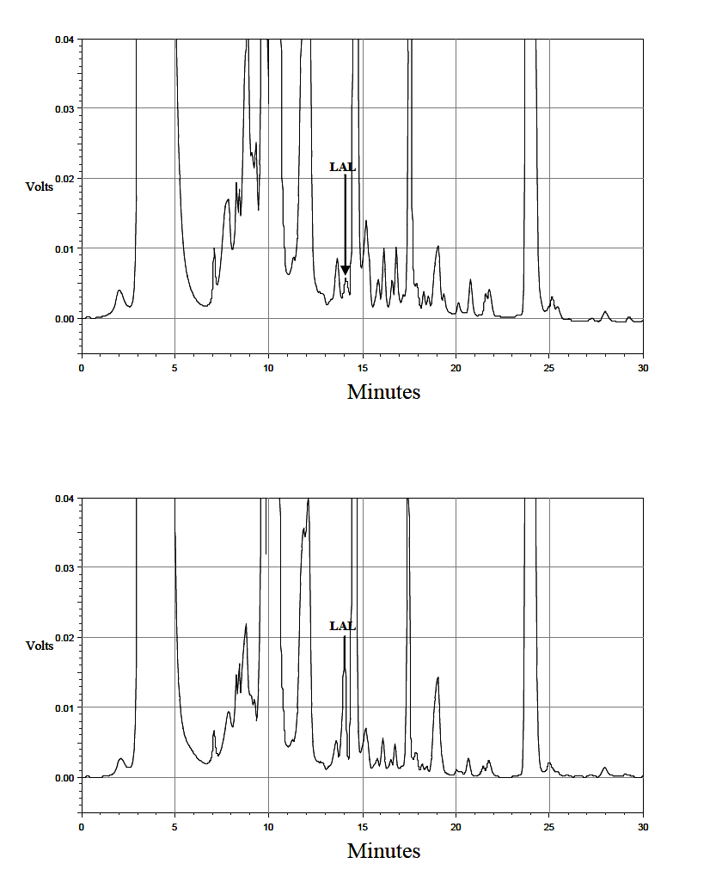

( b )

( a )

**Figure 1.** HPLC chromatograms of the dansyl derivatives of a hydrolysed milk sample (a) without and (b) with addition 100 ng lysinoalanine to the sample before acid hydrolysis

The calibration curve for LAL concentrations between 2 and 1000 ppm is shown in **Figure 2**. The regression equation was y =62.45x + 32 and the correlation coefficient *(r)* was 0.9994.



**Figure 2.** Calibration curve for lysinoalanine

The dansyl-LAL was stored for up to 15 days at -18 and 5 ºC and found to decrease by only 5.9 and 9.7% after 10 and 15 days at -18 ºC, respectively, while at 5 ºC the corresponding reductions were 15.3 and 17.8%. Similar storage stability was reported by Faist et al. (*7*)

**Method Validation.** Validation data are presented in **Table 1**. Recovery tests were performed by adding a known quantity of LAL to a sample of milk prior to hydrolysis and comparing the peak area of LAL present in the sample with that in the fortified sample. The recovery from six milk samples was 95–102%, which compares favourably with the 92% recovery found by Moret et al. (*21*).

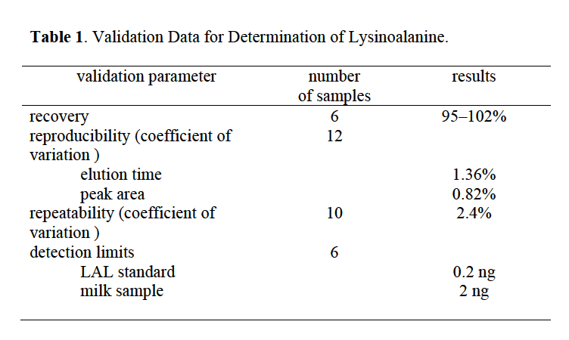

Reproducibility of the method was excellent; for example, the elution time of LAL in 12 serial injections varied by 1.36 %, while the variation in the peak area was 0.82%. The repeatability of the analysis was determined for a single sample of milk by repeating the entire analysis ten times; the results obtained had a coefficient of variation 2.4%.

The minimum detectable amount of LAL standard was found to be 0.2 ng, whereas in an actual milk sample it was 2 ng. The difference is due to the presence of other interfering substances in the sample, such as excess hydrolysed dansyl chloride (*21*). This result indicates that the detection limit for LAL by this method is slightly lower than by the method developed by Faist et al. (*7*) which can detect0.3 ng.

**Effect of Heat Treatment on LAL Concentration in Milk.** This new method was used to determine the increase in LAL concentration in milk during heating at 80 and 90ºC. The results in **Figure 3** show a distinct increase in LAL concentration with increased holding time at both temperatures, with LAL formation being higher at 90ºC than at 80ºC. The LAL content of the cows milk was 5.2 ppm of crude protein in unheated milk and this increased to 14.4 and 14.9 ppm crude protein after heating at

80ºC and 90ºC for 20 min. respectively. These results suggest that LAL concentration could be used as a marker for the severity of heat treatment of milk.



**Figure 3.** Effect of heating milk at 80 ºC (▲) and 90 ºC (■) on lysinoalanine concentration.

**Determination of LAL in Dairy Products.** TheLAL content of samples of raw cows milk was found to be 5.2–14.2 ppm (average, 9.4 ppm) of crude protein (**Table 2**). Similar data (2–24 ppm of crude protein) for raw cows milk were reported by Faist et al. (*7*).

The LAL concentrations in UHT-treated milk analysed in the present study were between 55.2 and 133.7 ppm (average, 87.1 ppm) of crude protein. Corresponding data for LAL in UHT milk from other studies range from 0 to 60 ppm (*13*) to 50–83 ppm of crude protein (*1*).

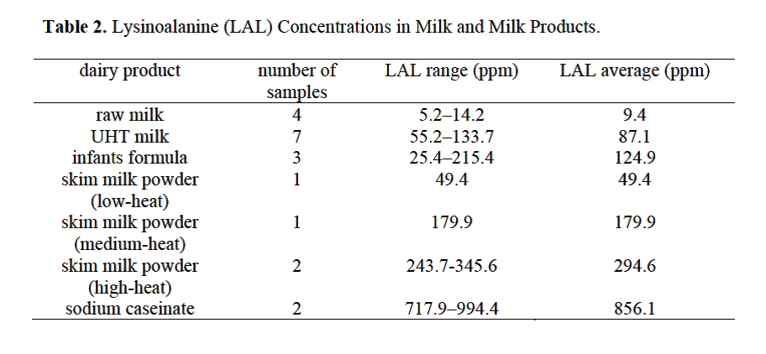

The LAL contents of infant formulas analysed were between 25.4 and 215.4 ppm (average, 124.9 ppm) of crude protein; these results are lower than those reported by Boschin et al. (*3*) which were 150–800 ppm of crude protein. These differences may reflect different processing methods and/or different formulations. Pfaff (*23*) and Pfaff and Pfaff (*24*) specified a limit of 200 ppm of crude protein for the LAL content of infant formula.

The LAL concentration of low-heat skim milk powder was 49.4 ppm of crude protein, and in medium-heat skim milk powder was 179.9 ppm of crude protein , while in high-heat skim milk powders the LAL range was 243.7 to 345.6 ppm of crude protein. This result is within the range of LAL concentrations reported by Friedman(*8*), which was 150–1620 ppm of crude protein.

In the present study the concentrations of LAL in sodium caseinate were the highest of all samples analysed. This is attributable to the use of sodium hydroxide in its preparation. The concentrations ranged from 717.9 to 994.4 ppm with an average of 856.1 ppm of crude protein. This result is lower than that found by Moret et al. (*21*), 2801 ppm, but within the range reported by Friedman (*8*) which was 430–6900 ppm of crude protein.

**CONCLUSIONS**

The present study shows the suitability of an improved RP-HPLC method based on dansyl derivatives for determining LAL in milk and dairy products. The derivatization method developed is easier and faster than the other derivatization methods and has similar accuracy. The concentrations of LAL in dairy products analysed by this method were generally in the same ranges as those determined by other methods.

**REFERENCES**

Antila, P.; Pullinen, E.; Antila, V. The formation and determination of lysinoalanine in foods containing milk protein. *Meijeritieteellinen Aikakauskirja* **1987**, *45*, 1-18.

Bayer, E.; Grom, E.; Kaltenegger, B.; Uhmann, R. Separation of amino acids by high performance liquid chromatography.*Anal. Chem.* **1976**, *48*, 1106-1109**.**

Boshin, G.; D'Agostina, A.; Rinaldi, A.; Arnoldi, A**.** Lysinoalanine content of formulas for enteral nutrition. *J. Dairy Sci.* **2003**, *86*, 2283-2287.

Corpet, D. E.; Tache, S.; Archer, M. C.; Bruce, R. W.(2008) Dehydroalanine and Lysinoalanine in Thermolyzed Casein do not Promote Colon Cancer in the Rat. Food *and Chemical Toxicology* , **2008**, *46 , 3037-3042*.

Corredig, M.; Dalgleish, D. The mechanisms of the heat-induced interaction of whey proteins with casein micelles in milk. *Int. Dairy J.* **1999**, *9*, 233-236.

**De Wit,** **J.** Nutritional and functional characteristics of whey proteins in food products. *J. Dairy Sci*. **1998**, *81*, 597-608.

Faist, V.; Drusch, S.; Kiesner, C.; Elmadfa, I.; Erbersdobler, H. Determination of lysinoalanine in foods containing milk protein by high-performance chromatography after derivatization with dansyl chloride. *Int. Dairy J.* **2000**, *10*, 339-346.

Struthers, B.; Hopkins, D.; Prescher,E. ; Dahlgren, R. Effects of protein-bound lysinoalanine, N{varepsilon}-DL-(2-amino-2-carboxyethyl)-L-lysine on fetal and neonatal rats. *J. Nutr*. **1978**, *108*, 954-958.

Friedman, M.; Gumbmann, M.; Masters, P.Protein alkali reactions: chemistry, toxicology, and nutritional consequences. *Adv. Exp. Med. Biol.* **1984**, *177*, 367–412.

Friedman, M.; Grosjean, O.; Zahnley, J.Inactivation of metalloenzymes by food constituents. *Food Chem. Toxicol.* **1986**, *24*, 497-502.

Friedman, M.; Zahnley, J.; Masters, P. Relationship between in vitro digestibility of casein and its content of lysinoalanine and D-amino acids. *J. Food Sci.* **1981**, *46*, 127-131.

Fritsch, R.; Hoffmann, H. ; Klostermeyer, H**.**. Formation of lysinoalanine during heat treatment of milk. *Z. Lebensm. Unters Forsch.* **1983**, *176*, 341-345.

Fritsch, R.; H. Klostermeyer.Occurrence of lysinoalanine in milk protein-containing foods. *Z. Lebensm. Unters. Forsch.* **1981**, *172,* 440-445.

Grose, C.; Labouesse, B.Study of the dansylation reaction of amino acids, peptides and proteins. *Eur. J. Biochem.* **1969**, *7*, 463-470.

Hasegawa, K.; Mukai, K.; Gotoh, M.; Honjo, S.; Matoba, T. Determination of lysinoalanine content in commercial foods by gas chromatography-selected ion monitoring. *Agric. Biol. Chem.* **1987**, *51*, 2889–2894.

Karayiannis, N.; MacGregor, J.; Bjeldanes, L**.** Biological effects of alkali-treated soy protein and lactalbumin in the rat and mouse. *Food Cosmet. Toxicol.* **1980**, *18*, 333–346.

Langhendries, J.; Hurrell, R.; Furniss, D.; Hischenhuber, C.; Finot, P.; Bernard, A.; Battisti, O.; Bertrand, J.; Senterre, J.Maillard reaction products and lysinoalanine: urinaryexcretion and the effects on kidney function of preterm infants fedheat-processed milk formula. *J. Pediat. Gastroenterol.**Nutr.***1992**, *14*, 62–70.

Liardon, R.; Friedman, M.; Philippossian, G. Racemization kinetics of free and protein-bound lysinoalanine (LAL) in strong acid media. Isomeric composition of bound LAL in processed proteins. *J. Agric. Food Chem.* **1991**, *39*, 531–537.

McClung, G.; Frankenberger, W. Comparison of reverse-phase high performance liquid chromatographic methods for precolumn derivatized amino acids. *J. Liquid Chromat*. **1988**, 11, 613-646.

Mni,L; Lokuruka,M. Effects of processing on soybean nutrients and potential impact on consumer health :an overview. *African J. of Food ,Agriculture ,Nutrition and Development* **2011** ,*11, 4,5000-5017*.

Moret, S.; Cherubin, S.; Rodriguez-Estrada, M.; Lercker, G. Determination of lysinoalanine by high performance liquid chromatography. *J. High Res. Chromat.* **1994**, *17*, 827-830.

Pellegrino, L.; Resmini, P.; De Noni, I.; Masotti, F**.** Sensitive determination of lysinoalanine for distinguishing natural from imitation Mozzarella cheese. *J. Dairy Sci*. **1996**, *79*, 725-734.

Pfaff, G. Lysinoalanine contents of formula diets. *Lancet* **1984**, *1*(8374), 448.

Pfaff, W.; Pfaff, G. Lysinoalanine content of weight reduction diets. *Apotheker. J.* **1984**, *5*, 57-59.

Sanderson, J.; Wall, J.; Donaldson, G.; Cavins, J**.** Effect of alkaline processing of corn on its amino acids. *Cereal Chem*. **1978**, *55*, 204–213.

Struthers, B.; Beilmaier, J.; Raymond, M.; Dahlgren, R.; Hopkins, D.Excretion and tissue distribution of radioactivelysinoalanine in Sprague-Dawley rats. *J.Nutr.* **1980**,*110*, 2065–2077.

Struthers, B. ; Dahlgren, R. ;Hopkins, D. Biological effects of feeding graded levels of alkali treated soybean protein containing protein-bound lysinoalanine in Sprague–Dawley and Wistar rats. *J. Food Sci.* **1977**, *107*, 1190–1199.

Struthers, B.; Hopkins, D.; Prescher,E. ; Dahlgren, R. Effects of protein-bound lysinoalanine, N{varepsilon}-DL-(2-amino-2-carboxyethyl)-L-lysine on fetal and neonatal rats. *J. Nutr*. **1978**, *108*, 954-958.

Tapuhi, Y.; Schmidt, D.; Lindner, W.; Karger, B**.** Dansylation of amino acids for liquid high performance liquid chromatography analysis. *Anal. Biochem.* **1981**, *115*, 123-129.

جاسم محمد صالح السعدي

قسم الصناعات الغذائية –الكلية التقنية الزراعية- حلبجة – سليمانية – العراق

المستلخص

**استخدم الكروماتوكرافي السائل عالي الكفاءة ذو الطور المعكوس في تقدير اللايسينوألنين في الحليب ومنتجات الالبان بعد تكوينه لمشتقة نتيجة لتفاعله مع كلوريد الدانسيل . أستعملت طريقة جديدة لتكوين مشتقة اللايسينوألنين في هذا البحث ، وقد كانت هذه الطريقة أسهل وأسرع وتتطلب مواد كيمياوية أقل مقارنة بالطرق الاخرى المعروفة المستخدمة لهذا الغرض. بلغت نسبة أسترداد نموذج اللايسينوألنين القياسي في هذه الطريقة 95-102%،بينما كانت قيمة معامل الاختلاف لكل من وقت الظهور و مساحة القمة وتكرار التحليل هي 1.36 , 0.82 و 2.4 % وعلى التوالي ، بينما بلغت أقل كمية من اللايسينوألنين يمكن الكشف عنها بهذه الطريقة هي 0.2 نانوغرام للنموذج القياسي و 2 نانوغرام بالنسبة لنماذج الحليب . كان متوسط تركيز اللايسينوألنين في الحليب الخام والحليب المعامل بالحرارة الفائقة 9.4 و 87.1 جزء بالمليون على التوالي ، بينما بلغ متوسط تركيز اللايسينوألنين في تركيبة حليب الاطفال ، مسحوق الحليب الفرز المجفف على حرارة واطئة ، مسحوق الحليب الفرز المجفف على حرارة متوسطة ، مسحوق الحليب الفرز المجفف على حرارة عالية وكازينات الصوديوم 124.9 ,49.4 ,179.9 ,294.6 و856.1 جزء بالمليون وعلى التوالي.**