THE TITLE
First Author¹, Second Author² and Third Author³
1 description of the first Author consists of scientific title, affiliation and email
2 same as above for the second author
3 same as above for the third author
ABSTRACT
The abstract should be no more than 150 words, in the first page with title, authors' name and keywords. Normal text is Times New Roman Font size 12 with single line space.
keywords
List 5 To 10 Words Which Related To The Paper, Times New Roman Font Size 12 With Capital Letter For The First Word.

- introduction
The introduction text and the normal text is times new roman font size 12.
The total pages of the whole paper must be not more than 12 pages.
Consider the following structure for the experimental paper:
Introduction/aim/background
Methodology
Results and discussion
Conclusion
Acknowledgements
References
- Next main heading
  - Sub-heading

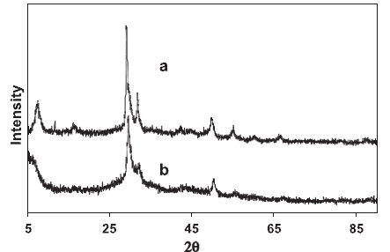
Fig. 1. Captions are placed underneath

    - Sub-sub-heading

Click on Styles to see the journal styles available
Main text is Times New Roman Font size 12.

- Results
Table 1. Table headings are placed above the table
Rows | Column 1 | Column 2
1 | 20 | 12
2 | 400 | 144

(1)

Equations should be placed in the center with a bracketed number right justified. The tabs have already been setup in the Journal equation style item.
- conclusions
Normal text is Times New Roman Font size 12

- references
The style of the references must be according to Harvard style.
Aaronson, A. and Biggins, B. (2005a) 'Quantitiative methods', European Journal of Research Methods, 9(7), 10-13.
Aaronson, A. and Biggins, B. (2011) A primer in essential methodology, 3rd ed., London, Ontario: Niagra University Press.
Bezemer, D. J. (2010) 'Understanding financial crisis through accounting models', Accounting, Organisation and Society, 35(7), 676-688, available: http://dx.doi.org/10.1016/j.aos.2010.07.002 [accessed 12 January, 2012].
Kindly, remember that the total pages of the whole paper must be not more than 12 pages.

