Manuscript template – KUFA Journal for Veterinary Medical Sciences
(Please refer instructions to authors and latest articles at https://journal.uokufa.edu.iq/index.php/kjvs/guide_authors/for format/style of each section)

REVIEW ARTICLE: There is no specific format for review article. Minimum 50% references must be from past five years.

RESEARCH ARTICLE
IMPORTANT
Whole document should be in one column only.
Give reference no. in the text starting from no. 1 onwards and arrange the references in the reference list accordingly.

Title: Should be bold, clear, descriptive, not too long, avoid abbreviations and formulae where possible

Authors’ name

Ahmed Hameed Al-Azam¹, Falah Hasan Baiee^{2*}, and Asmatullah Kaka³

¹ Department of Pathology, Faculty of Veterinary Medicine, University of Kufa, Najaf Iraq. E-mail: Ahmed H Al-Azam@uokufa.edu.iq
² Department of Veterinary Clinical Studies, Faculty of Veterinary Medicine, University Putra Malaysia, UPM Serdang, Selangor, Malaysia.
E-mail: falahhali@uokufa.edu.iq
³ Department of Animal Reproduction, Faculty of Animal Husbandry and Veterinary Sciences, Sindh Agriculture University, Pakistan.
E-mail: Asmatullah Kaka@uuuuuuuuu

*Correspondence: Falah Hasan Baiee Department of Veterinary Clinical Studies, Faculty of Veterinary Medicine, University Putra Malaysia, UPM Serdang, Selangor,Malaysia. E-mail: falahhali@uokufa.edu.iq

(Received 15 Jun 2018, revised version 5 May 2018, accepted 14 May 2018)

ABSTRACT
The abstract should not exceed 200 words in single paragraph for all type of manuscripts. The abstract should state briefly the background and/or aim, materials and methods, results, conclusion, An Arabic abstract is required for manuscripts which written in English (solely Arabic native speaker) and it should follow the English abstract.

Key words: Keywords: 3-6. It should be in alphabetical order.

INTRODUCTION
It should be in three or more paragraph. Second last paragraph should contain the significance of the research and last paragraph should contain aim of the study.

MATERIALS AND METHODS
Ethical approval: It is compulsory when you use any live animal for research/study or collect the samples from live animal. Consent should be obtained in case of human samples or information.
Study area:
Animals:
Experimental design:
Tests, procedures etc.:
Statistical analysis:
You may add or delete the subheading as per your research.

RESULTS
This section should contain results of your research. Give subheadings if necessary.

All tables should be prepared in a form consistent with recent issues of KUFA and should be numbered consecutively with Arabic numbers. (Table 1).

Table 1. This is an example of a table
Ingredient | P₁ | P₂
T* | X | 2
C* | g | 1
F* | g | 1
P** | IU | IU
E |  | D
* Sigma Aldrich Co. Sigma., St. Louis, MO, USA
**15140122, gibco® USA.

Referring to actual words that merely fill the spaces between the important words—words that simply fill up verbal space and empty out the narrativ (Fig. 1).

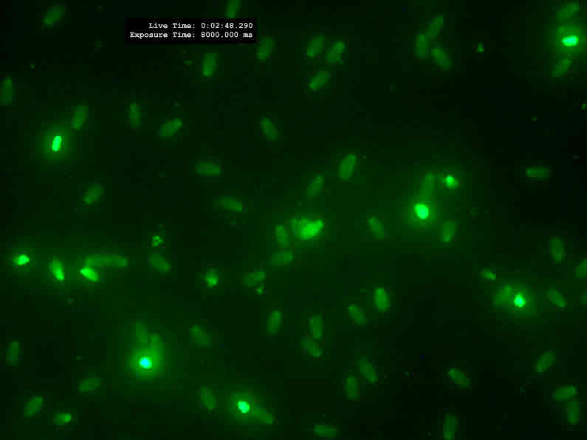
Example figure
Fig. 1. Example of an image with acceptable resolution

DISCUSSION
This section should contain Discussion of your results. It should provide an interpretation of the results in relation to previously published work and to the experimental system at hand (give preference to last five year studies). Discuss the factors responsible for your results. Give subheadings if necessary. It should consider the results in relation to any hypotheses advanced in the introduction. This may include an evaluation of the methodology and of the relationship of new information to the knowledge in that field. It must not contain extensive repetition of the results section or reiteration of the introduction.

CONCLUSION
To mention the main outcome of the paper and the most important evidence (extract of your results). Please do not repeat the results data of your research here.

RECOMMENDATIONS if any:

ACKNOWLEDGEMENT
Use same font size for the content of acknowledgements section.

CONFLICT OF INTEREST
Declare the competing interests, if any otherwise declare that authors have no competing interests.

REFERENCES
References must be as per journal style. All journal abbreviation must be as per standard journal abbreviation. Research article: 40% references must be of research/review papers published during past five years. Review article: 40-50% references must from papers published during past five years. References in the text should be given by placing in bracket [1], [1,2,3]. Reference no. should start from no. 1 onwards from Introduction section (e.g.: [1], [2]...[1,2]). Reference list must be prepared accordingly.
Note: journals should contain DOI at the end of each reference.

Journal style:

1. Bingham CM, Wilson PR, Davies AS. Real-time ultrasonography for pregnancy diagnosis and estimation of fetal age in farmed red deer. Vet Rec. 1990;126(5):102–6. Doi: 10.23.23455.6565.837363

Book style:

2. Wanamaker BP PC. Applied pharmacology for the veterinary technician. 1st ed. Philadelphia: WB Saunders Company; 1996. p 372.

Chapter in a book style:

3. Chabala JC, Miller MW. Chemistry of antiprotozoal agents. In: Chemotherapy
of Parasitic Diseases. Springer; 1986. p. 25–85.

Ph.D. thesis style:

4. Zhao C. Development of nanoelectrospray and application to protein research and drug discovery. State University of New York at Buffalo; 2005.

Specific pages or documents within a website style:

5. Organisation WH. Financial crisis and global health [Internet]. The United Nations. 2013 [cited 2013 Aug 1]. Available from: http://www.who.int/topics/financial_crisis/en/

For any query, please contact editorial office at: abdullaho.mansour@uokufa.edu.iq

