Statement of Permission and Conflict of Interests

Note\\ Fill in the blanks the required information and only one signed copy attached with the manuscript.
Please omit this note before submitting…

Manuscript Title: …………………………………………………………………………….

I/we certify that I/we grant permission to the editor board of Kufa Medical Journal to make necessary changes as per the request of journal, to use, publish, reproduce, transmit, download, upload post, display or otherwise distribute our submissions in any manner without notice us.

I/we declare that I/we have no any financial interests or connections, direct or indirect, or other situations that might raise the question of bias in the work reported or the conclusions, implications or opinions stated – including pertinent commercial or other sources of funding for the individual author(s) or for the associated department(s) or organization(s), personal relationships, or direct academic competition.

Best regards

 | Name | Date signed | Signature
1 |  |  | 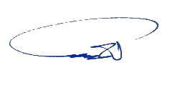
2 | …
3 | …
4 | …
5 | …

